Are you ready for MTH 131?

The purpose of this review is to verify your readiness these math courses.
You do not need to solve these problems.
Simply review them and answer the three questions below.
- Do these math problems below look familiar to you?
- Have you learned these types of problems in prior math classes?
- If you reviewed this material, would you be able to solve most of these problems?

- Simplify the following expressions
  - $\frac{-6+(-2)}{-3+1}$ b. $(-2)^{3 }+(-3)(2)$ c. $9\frac{1}{4}-2\frac{2}{3}$
- Answer the following problems involving percents
- What is 40% of 380?
- What percent of 80 is 72?
- Convert 0.3 to a percent.
3a. Solve each equation.
- $2x+6=5$ b. $3x=6$ c. $3(x-5)=4$

3b. Plot the point (-3,4) on the coordinate plane below.
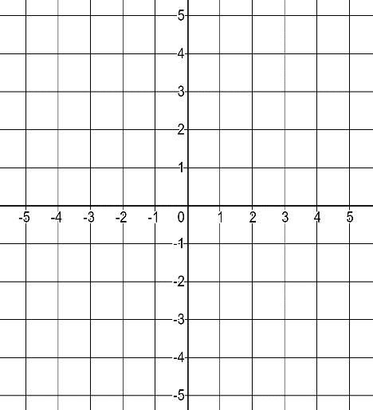

5. Write the following numbers in scientific notation.
- $0.00345$ b. $324,567,000$

6. Write the following scientific numbers in standard notation.
- $1.23 x 10^{5}$ b. $3.67 x 10^{-4}$

GENERAL COURSE PLACEMENT RECOMMENDATIONS
- If you answered yes to at least one of the questions, you should consider enrolling in MTH 131.

- If you answered no to all three questions, you must enroll in pre-requisite development courses. Please contact an advisor.

